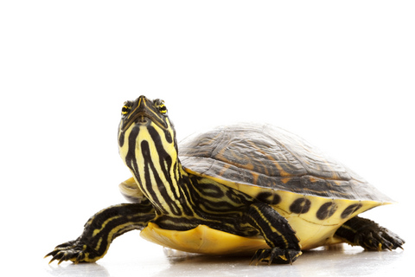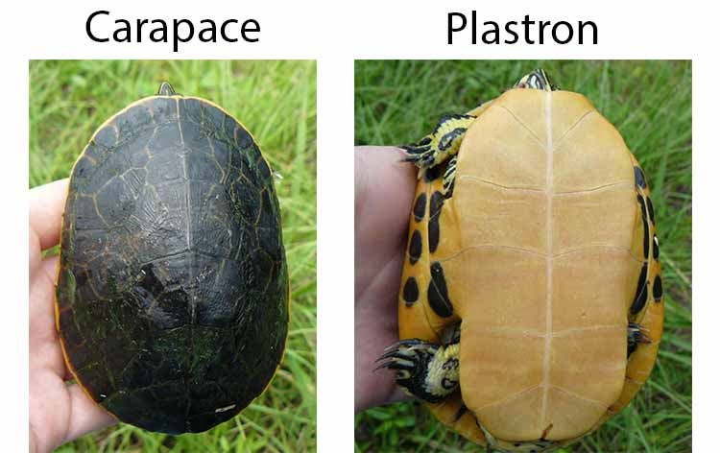**Yellow bellied slider Turtle images:**

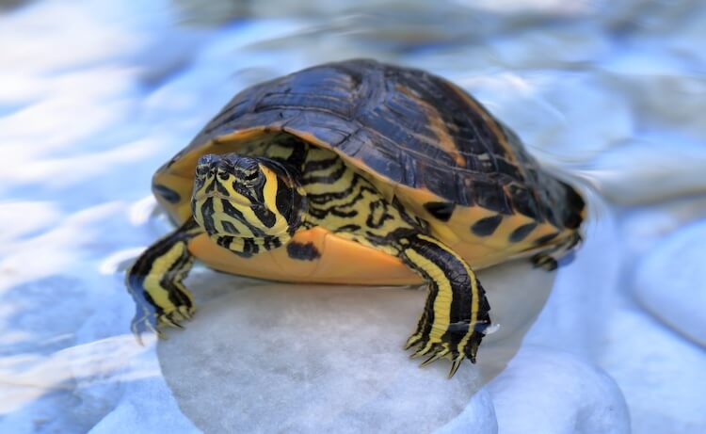

**Corn Snake images:**

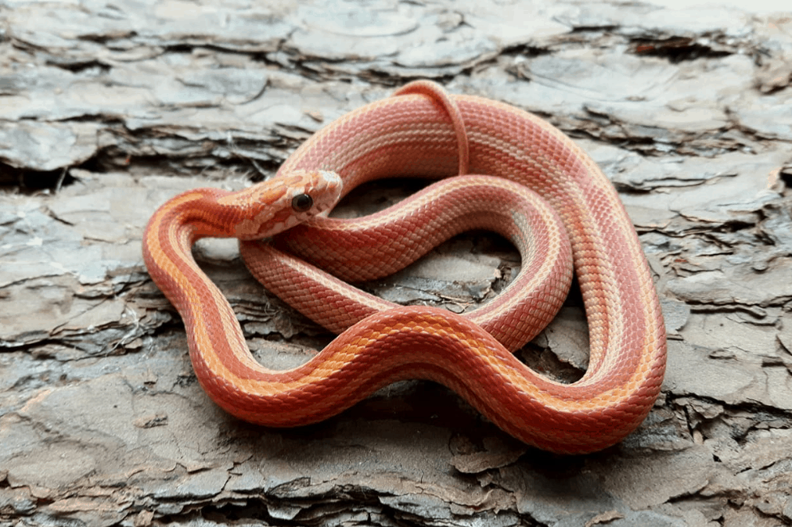

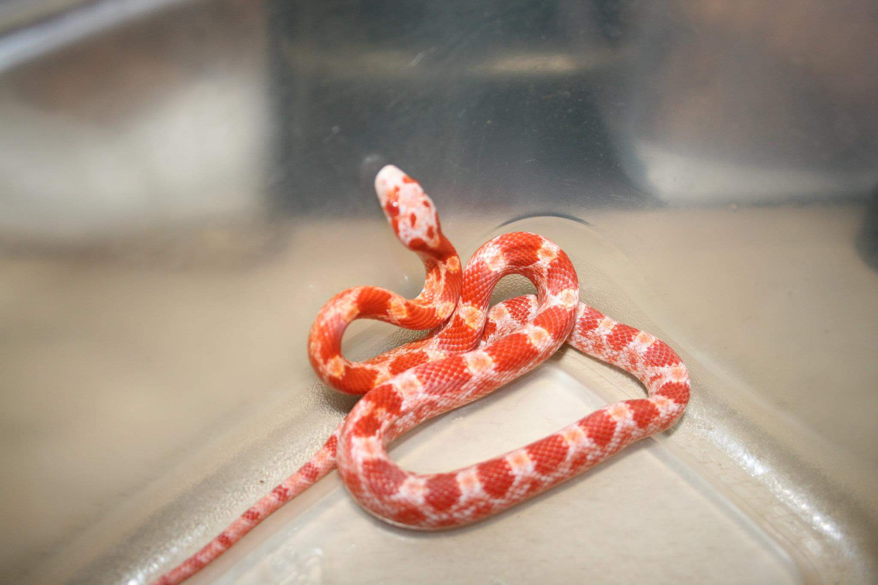

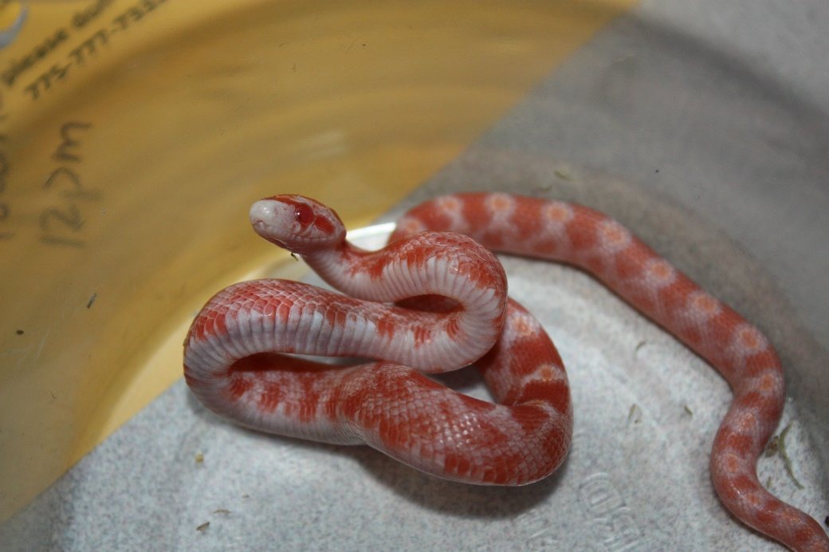

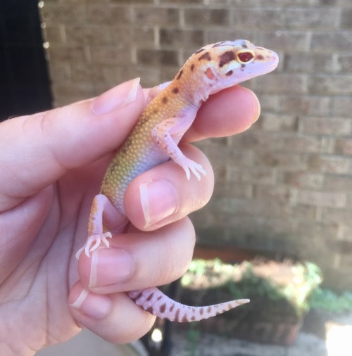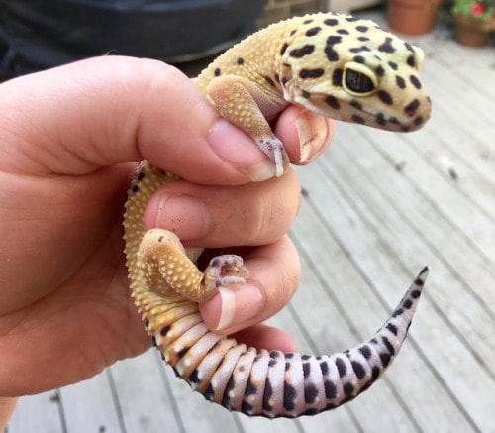**Leopard gecko images:**

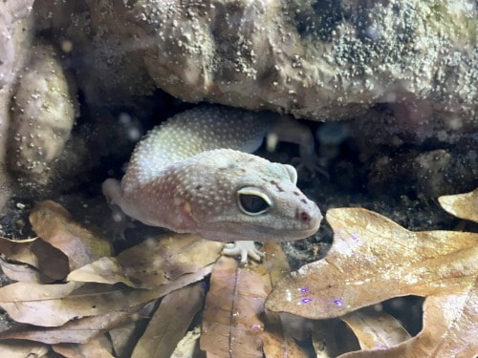

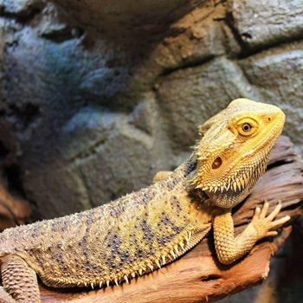**Bearded Dragon:**

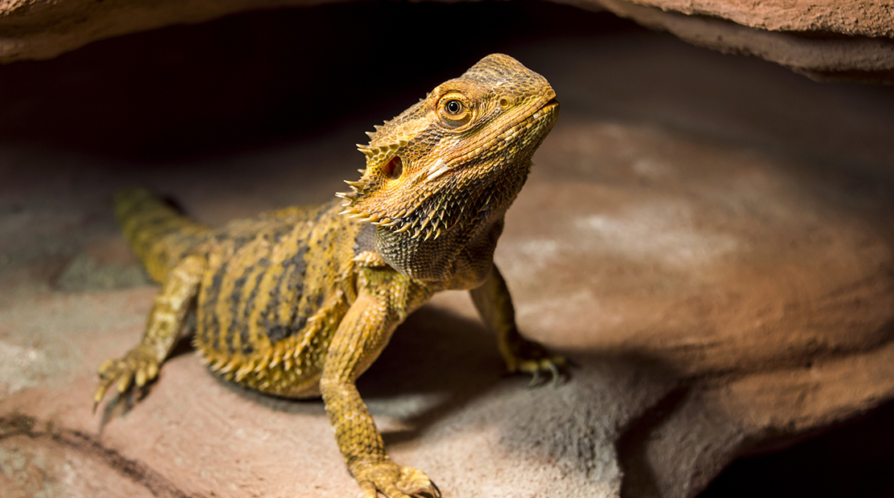

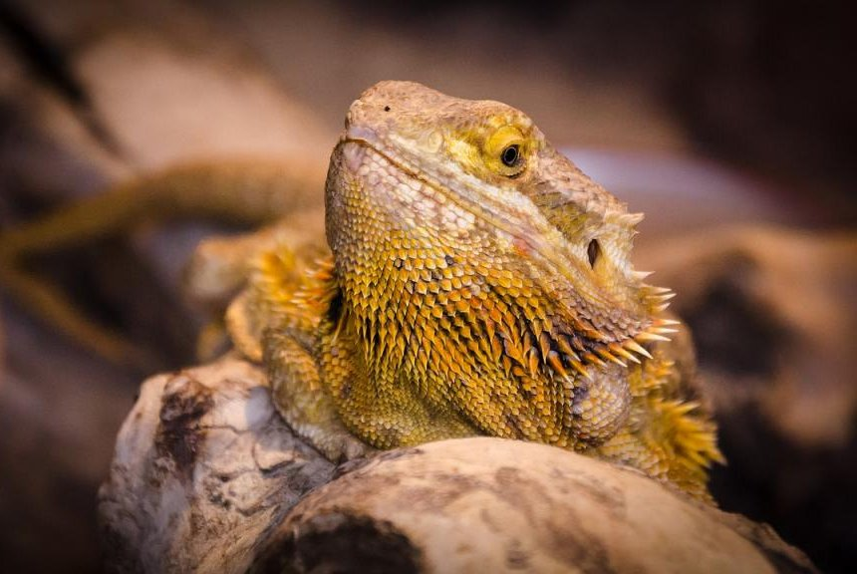

**Ball Python Snake:**

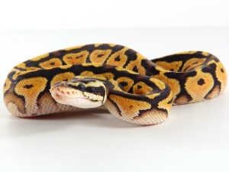

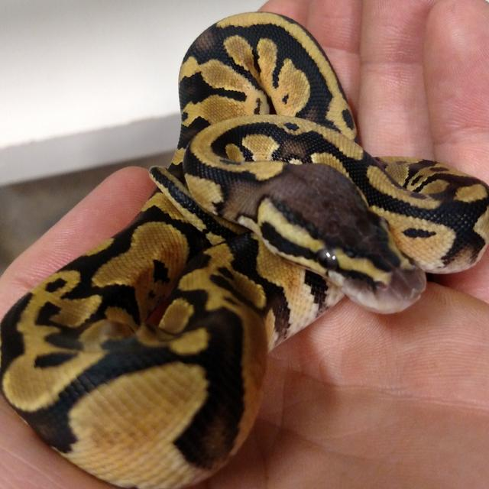

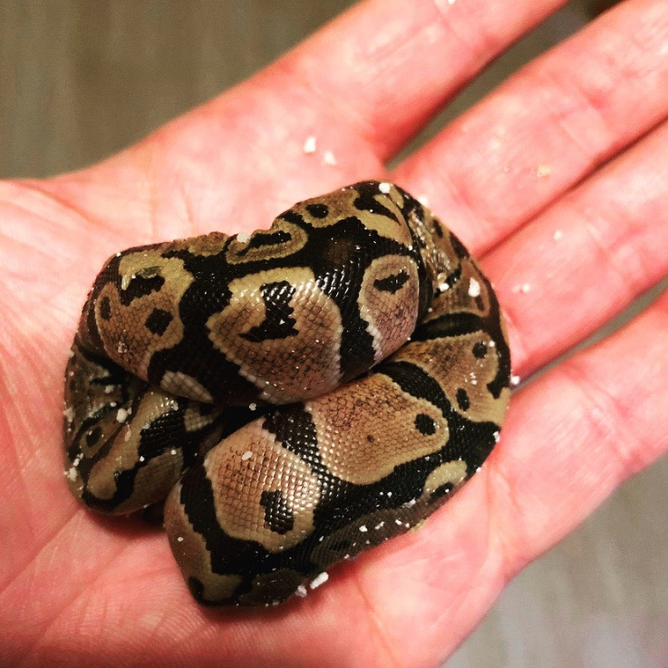

**Read Eared Slider Turtle:**

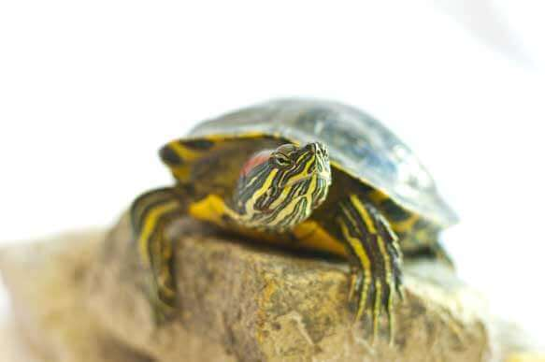

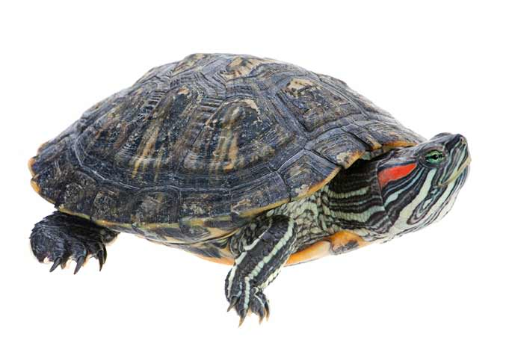

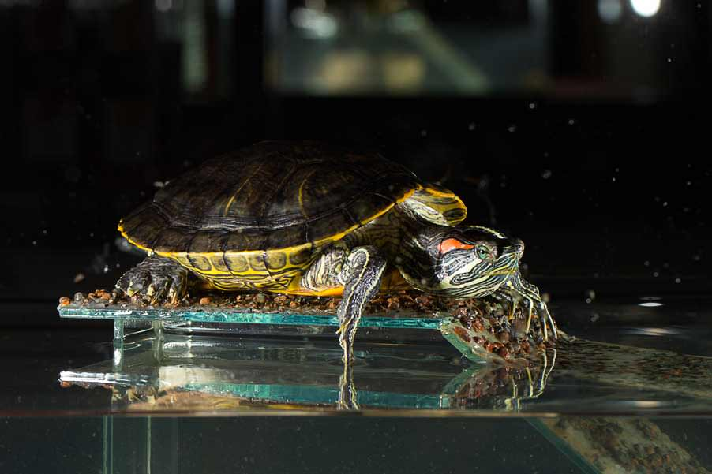

Welcome to Safe Scales!

We want to use our platform to sell reptiles ethically and make sure they go to good homes to prepared buyers.

We require all customers to go through an ‘approval process’. Where you choose a reptile you want to purchase and go through the payment process. After this your order will be in the approval stage and not yet confirmed.

1. First you must provide proof that you have the correct set up and understanding of care for your chosen reptile.
2. Submit at least 1 document into the approval section. This could be an order confirmation email for a set up or an image of the set up/food/correct equipment for the reptile (your order will be in the approval process for 2 days, if no evidence is provided it will automatically be cancelled)
3. Your evidence is then checked.
4. It will then either be confirmed or denied.

If you order is denied you will be automatically refunded, and the reptile will be available for others to purchase.

Research shows that more and more people are purchasing exotic animals like reptiles and due to the lack of understanding on how to care for these animals, they are often neglected, and some are abandoned. Our mission is to decrease this and prevent it as much as we can by ensuring all our customers are informed about the reptile they wish to purchase.